MERN Application Deployment Report
Infrastructure Automation with Terraform & Ansible
1. Executive Summary & Objective
The objective of this project was to automate the end-to-end infrastructure provisioning and application configuration for the TravelMemory MERN-stack application on AWS.
Using Terraform, an isolated multi-subnet Virtual Private Cloud (VPC) was created along with necessary security groups, routing rules, and EC2 instances. Using Ansible, configuration management was automated to setup Node.js, PM2, and Nginx on the public web server, and secure MongoDB on the isolated database server.
- GitHub Repository: [https://github.com/vivek-rajendran/TravelMemory](https://github.com/vivek-rajendran/TravelMemory)
- Application URL: [http://65.0.3.141](http://65.0.3.141)
2. Infrastructure Architecture Overview (Terraform)
The underlying cloud infrastructure was declared and provisioned using Terraform scripts (main.tf, variables.tf, outputs.tf).
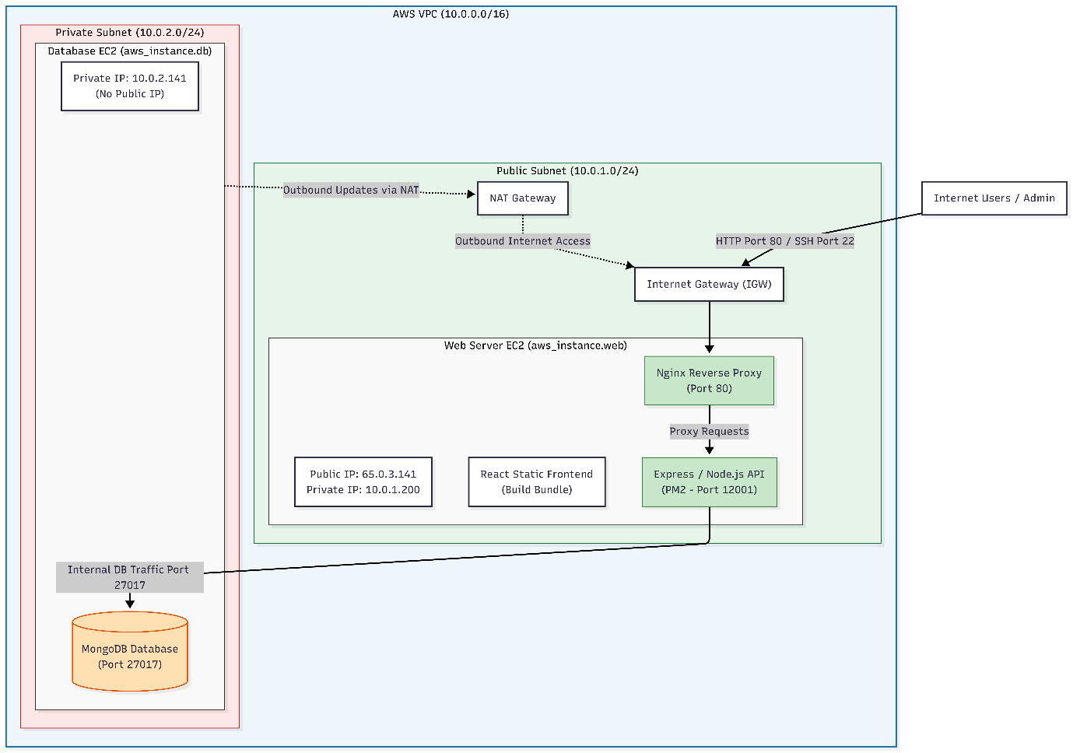
Network & Compute Specifications
- VPC Network: 10.0.0.0/16 CIDR block providing network boundary isolation.
- Public Subnet (10.0.1.0/24): Associated with an Internet Gateway (IGW) to handle inbound/outbound traffic for the public web node.
- Private Subnet (10.0.2.0/24): Associated with a NAT Gateway located in the public subnet, allowing the database instance to download software updates securely without exposing public IP addresses.
- Web Server EC2 (aws_instance.web): Provisioned in the Public Subnet with Elastic/Public IP 65.0.3.141 and private IP 10.0.1.200.
- Database EC2 (aws_instance.db): Provisioned in the Private Subnet with internal IP 10.0.2.141 and no public IP assigned.
3. Configuration Management & Deployment (Ansible)
Configuration and deployment were divided into modular Ansible playbooks executed against an inventory defined in inventory.ini.
Bastion Host / ProxyJump Pattern
To communicate with the database instance isolated inside the private subnet, Ansible was configured using SSH ProxyJump through the web server:
Ini, TOML
[db:vars]
ansible_ssh_common_args='-o StrictHostKeyChecking=no -o UserKnownHostsFile=/dev/null -o ProxyJump=ubuntu@65.0.3.141'
Playbook Breakdown
- Web Server Setup (setup-web.yml):
  - Installed Node.js (v18+), NPM, PM2 process manager, and Nginx web server.
  - Configured initial system permissions and dependencies.
- Database Setup (setup-db.yml):
  - Automated installation of MongoDB Community Edition on 10.0.2.141.
  - Updated mongod.conf to bind MongoDB strictly to local network interface 0.0.0.0 or internal private IP 10.0.2.141, enabling connections from the web subnet while blocking public access.
- Application Deployment (deploy-app.yml):
  - Backend: Cloned TravelMemory repo, installed dependencies, configured .env with PORT=12001 and MONGO_URI=mongodb://10.0.2.141:27017/travelmemory, and started the process under PM2.
  - Frontend: Injected REACT_APP_BACKEND_URL="[http://65.0.3.141](http://65.0.3.141)" during npm run build compilation to ensure clients send API calls to the public IP endpoint.
  - Nginx Reverse Proxy: Configured Nginx to serve the static frontend React build on port 80 and reverse-proxy API requests matching /trip and /url to [http://127.0.0.1:12001](http://127.0.0.1:12001).
4. Security Hardening & Isolation
- Network Perimeter Hardening (db_sg): The database Security Group ingress rules restrict SSH (Port 22) and MongoDB (Port 27017) traffic exclusively to the Web Subnet CIDR block (10.0.1.0/24). direct access from the internet is completely blocked.
- Web Security Group (web_sg): Allows public ingress on Port 80 (HTTP) for application users, while SSH access on Port 22 is restricted to authorized administrative IPs.
- SSH Key Pair Authentication: Password-based SSH authentication was disabled across all nodes in favor of asymmetric SSH key pairs (travelmemory-key).
- Non-Root Execution: Node.js services are run under a dedicated system user (ubuntu) managed via PM2 process manager rather than system root.
5. Verification & Deliverable Evidence
(Note: Attach your screenshots in this section before exporting to PDF)
- [INSERT SCREENSHOT 1]: AWS Console
  - Description: Showing web_server (Public IP 65.0.3.141) and db_server (Private IP 10.0.2.141) in running state.
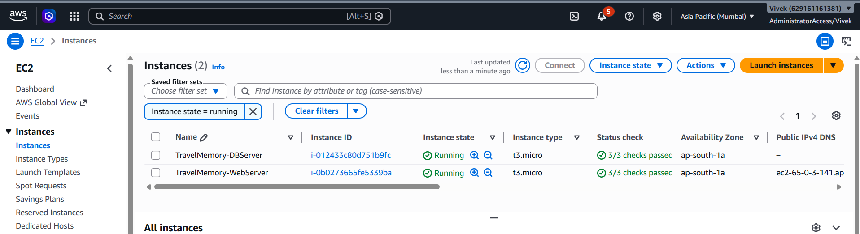
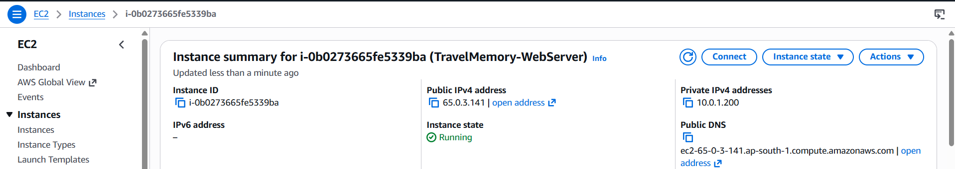

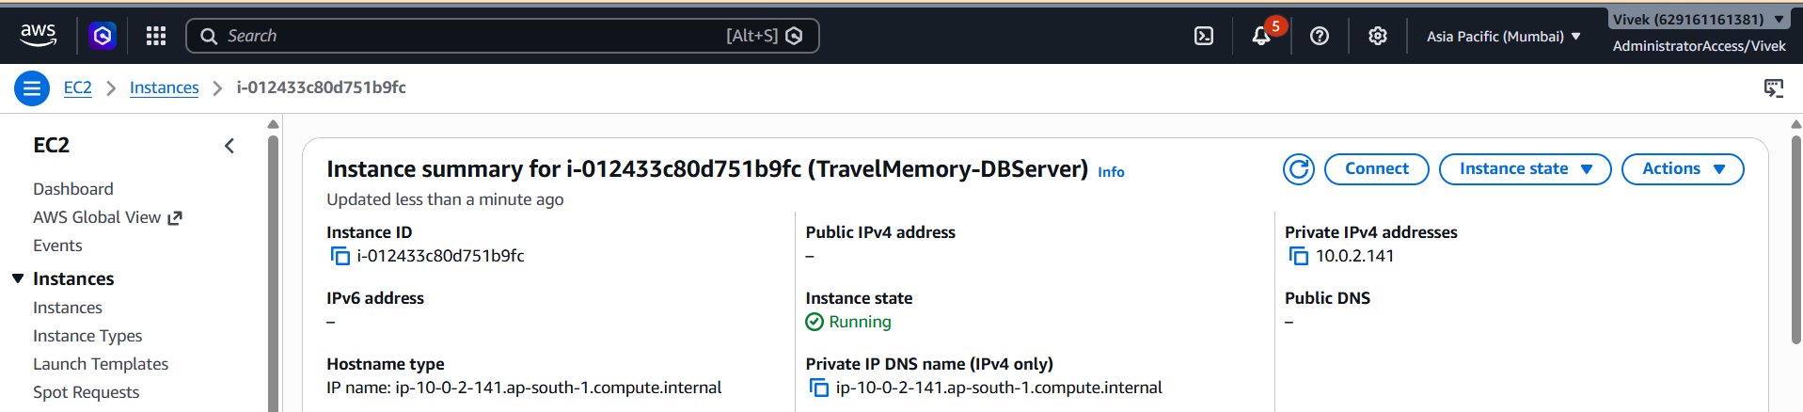
- [INSERT SCREENSHOT 2]: Ansible Execution
  - Description: Output of ansible all -m ping returning "ping": "pong" across both hosts via ProxyJump.
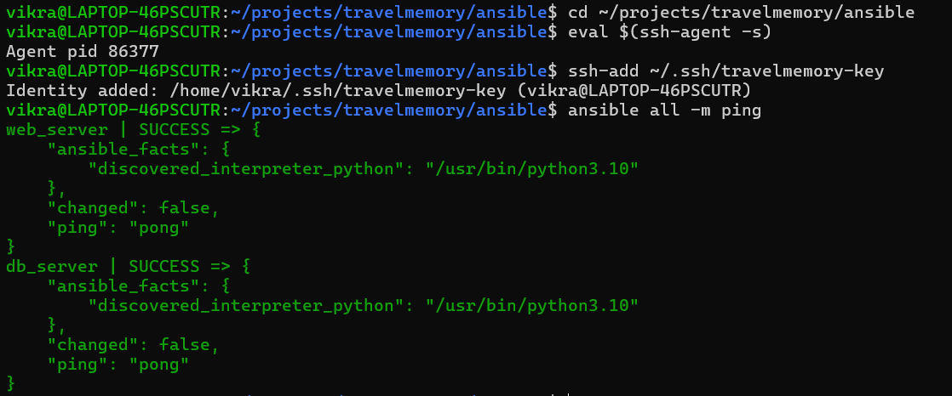
- [INSERT SCREENSHOT 3]: Live Application Interface
  - Description: TravelMemory application rendered in browser at [http://65.0.3.141](http://65.0.3.141).
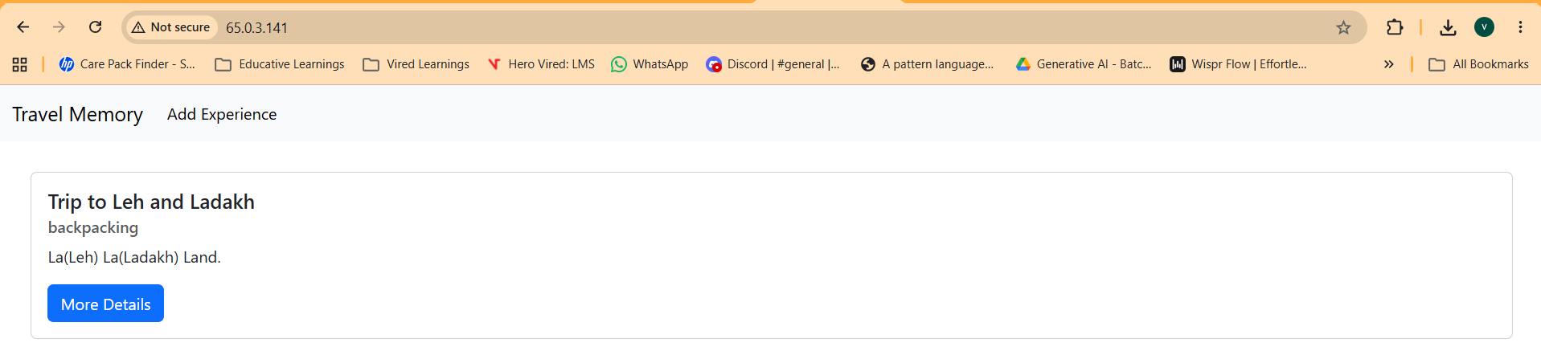
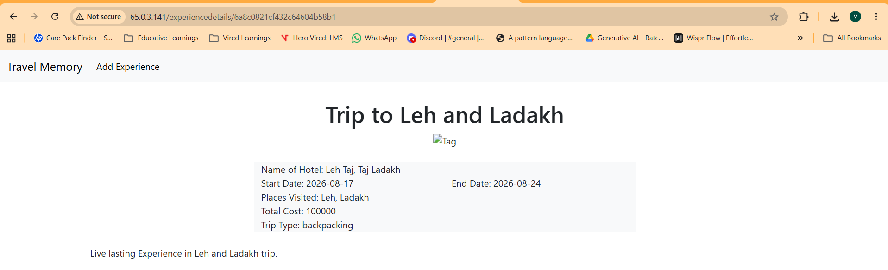
- [INSERT SCREENSHOT 4]: DevTools Network Verification
  - Description: Chrome DevTools showing successful 200 OK POST response for /trip endpoint calls.
